Important Submission Guidelines:
- Preferred presentation mode (oral/poster) and topic must be indicated during submission.
- Abstract must be submitted in PDF via the conference website’s submission form.
- Language: English; Length: Maximum 2 pages (1-inch margins, single spacing, Times New Roman).
- Presenting author: Maximum 1 oral and/or 1 poster presentation per registered individual; Final acceptance requires the presenting author’s registration.
Title of the abstract (bold, times new roman, 14 pts)
A. Name,ª B. B. Name,^{b} and C. Author^{b,}* (times new roman, 10 pts, aligned left. The underlined author indicates who will be the presenting author)
ªAuthor’s affiliation, City, Zip code, Country (times new roman, 10 pts)
^{b}Author’s affiliation, City, Zip code, Country (times new roman, 10 pts)
*Corresponding author: E-mail address (Only one corresponding author allowed for further notifications, times new roman, 10 pts)
Keywords (Times New Roman, 10 pts, italicized): Keyword 1, Keyword 2, Keyword 3 (3-5 maximum)
- INTRODUCTION (times new roman, 10 pts, aligned left)
Include scientific background, research novelty, and main objectives. (times new roman, 10 pts, fully justified.)
- EXPERIMENTAL (times new roman, 10 pts, aligned left)
Include simple experimental processes. (times new roman, 10 pts, fully justified.)
- RESULTS AND DISCUSSION (times new roman, 10 pts, aligned left)
Present core results (focus on key findings); include tables/figures if applicable. (times new roman, 10 pts, fully justified.)
Guidelines for Figures and Tables:

Table 1 - Table caption (EAZC2027_Figure-Table_caption) | 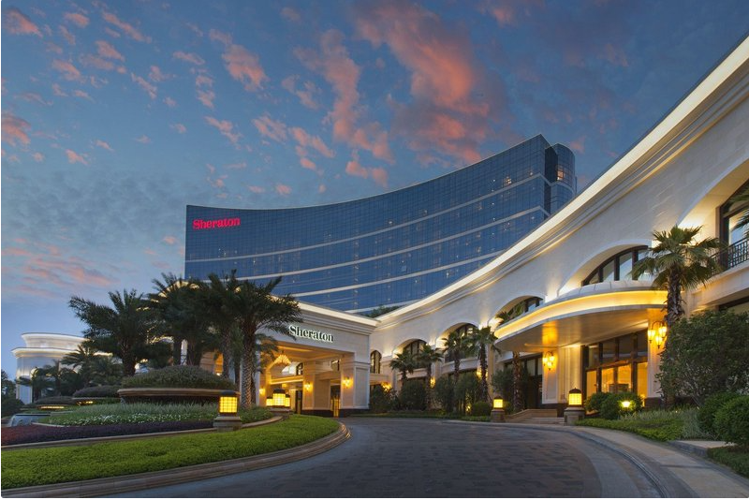  Figure 1 - Figure Caption (EAZC2027_Figure-Table_caption)
  Catalyst | xxxx | xxx
  Cat1 | xx | xx
  Cat2 | xx | xx
- CONCLUSIONS (times new roman, 10 pts, aligned left)
Focus on scientific contributions and key implications; avoid redundant summaries. (times new roman, 10 pts, fully justified.)

References (times new roman, 10 pts, left-aligned)
[1] A. Author, B. Author, and C. Author, Journal, Volume, Page (Year).
[2] A. Author, Title of Book, Publisher, City (Year).
[3] A. Author and B. Author, Conference, Dates, City, Country, Page (Year).

Acknowledgments (if applicable, times new roman, 10 pts, left-aligned italicized, fully justified.)
Append at the bottom of the abstract; include funding sources, institutional support, etc. (times new roman, 10 pts, italicized, fully justified.)

